CSE/NLM Guide – 8th Ed.
This is a basic guide to the CSE style of citation, as used in the Journal of Food Science. For more in-depth information, please see:
- Scientific Style and Format: The CSE Manual for Authors, Editors, and Publishers (8th Edition) Call # for Brescia copy: Q180.3.S41 2014 (No Loan Reference).
- Citing Medicine: The NLM Style Guide for Authors, Editors and Publishers (2nd Edition) - Through Western Libraries or at http://www.ncbi.nlm.nih.gov/books/NBK7256/
This style relies on journal abbreviations. For assistance with abbreviating journal titles, try:
- The NLM Journal Catalog: http://www.ncbi.nlm.nih.gov/nlmcatalog/journals
- Web of Science:
https://images.webofknowledge.com/images/help/WOS/A_abrvjt.html

Note: This guide follows the Name-Year format, corresponding with the format used in the Journal of Food Science. The other citation systems accepted are: Citation-Sequence (endnote citation used in-text, in sequential order) and Citation-Name (endnote citations used in-text, numbers assigned).
Books
 | In-text citation | References
Single author | (Author Year) | Author AA. Year. Title. Location: Publisher. Total #p.
 | (Macosko 1994) | Macosko CW. 1994. Rheology: principles, measurements, and applications. Berlin: Wiley-V CH. 568 p.
Two authors | (Author and  Author Year) | Author AA, Author BB. Year. Title. Location: Publisher. Total #p.
 | (Giesbrecht FG and  Gumpertz ML 2004) | Giesbrecht FG, Gumpertz ML. 2004. Planning, construction, and statistical analysis of comparative experiments. New York: Wiley. 693 p.
Three or more authors | (Author and others Year) | Author AA, Author BB, Author CC. Year. Title. Location: Publisher. Total #p.
 | (Koutchma and others 2009) | Koutchma TN, Forney LJ, Moraru CI. 2009. Ultraviolet light in food technology principles and applications. New York: CRC Press. 278 p.
Editor in place of author | (Editor and Editor  Year) | Editor AA, Editor BB, editors. Year. Title. Location: Publisher. Total #p.
 | (Leeper and  Vederas 2000) | Leeper FJ, Vederas JC, editors. 2000. Biosynthesis: polyketides and vitamins. New York: Springer. 205 p.

Editor and author | (Author Year) | Author AA, Author BB. Year. Title of book. Editor AA, Editor BB, editors. Location: Publisher. Total #p.
 | (Martin 1978) | Martin EW. 1978. Hazards of medication. Ruskin A, Napke E, Alexander S, Kelsey FO, Farage DJ, Mills DH, Elkas RW, editors. Philadelphia: Lippincott. 686 p.
Organization as author | (Organization abbreviation Year) | [Abbreviation] Organization Name. Year. Title of book. Location: Publisher.
 | (WHO 2007) | [WHO] World Health Organisation. 2007. Reducing salt intake in populations:  report of a WHO forum and technical meeting. Geneva: WHO Production Services.
Multiple editions | (Author and  Author Year) | Author AA, Author BB. Year. Title of book. # ed. Location: Publisher. Total #p.
 | (Schott and Priest  2002) | Schott J, Priest J. 2002. Leading antenatal classes: a practical guide. 2nd ed. Boston (MA): Books for Midwives. 268 p.
Multiple volumes | (Author/Editor  Year) | Author/Editor AA. Year. Title of volume. Location: Publisher. (Title of series; vol. #). Total #p.
 | (Ambudkar and  Gottesman 1998) | Ambudkar SV, Gottesman MM, editors. 1998. ABC transporters: biochemical, cellular, and molecular aspects. San Diego (CA): Academic Press. (Methods in enzymology; vol. 292). 853 p.
Chapter in book | (Author Year) | Chapter Author AA. Year. Title of chapter. In: Editor AA, Editor BB, editors. Title of book. Edition. Location: Publisher. Chapter pages.
 | (Rich and Ellis  1998) | Rich RQ, Ellis MT. 1998. Lipid oxidation in fish muscle. In: Moody JJ, Lasky UV, editors. Lipid oxidation in food. 6th ed. New York: Pergamon. p 832-55.
Electronic book | (Author Year) | Author AA. Year. Title of book [Medium]. Edition (if applicable).  Location: Publisher. [date updated; date accessed]. Available from URL.
 | (Richardson 2006) | Richardson ML. 2006. Approaches to differential diagnosis in musculoskeletal imaging [Internet]. Version 2.0. Seattle (WA): University of Washington School of Medicine. [Updated 12 June 2008; Accessed 20 May 2010].  Available from: http://www.rad.washington.edu/mskbook/index.html.
Dictionary entry - online version | (Title Year) | Title of dictionary [Internet]. Location: Publisher; Date [cited Date]. Available from: URL.
 | (Merriam-Webster  2005) | Merriam-Webster medical dictionary [Internet]. c2005. Springfield (MA):  Merriam-Webster Incorporated; [cited 2006 Nov 16]. Available from: http://www.nlm.nih.gov/medlineplus/mplusdictionary.html.
Encyclopedia entry - online version | (Title Year) | Title of encyclopedia [Internet]. Location: Publisher; Date [cited Date]. Available from: URL.
 | (A. D. A. M. 2005). | A.D.A.M. medical encyclopedia [Internet]. c2005. Atlanta (GA): A.D.A.M., Inc.; [cited 2006 Nov 3]. Available from: http://www.nlm.nih.gov/medlineplus/encyclopedia.html.
Further examples for Books, Dictionaries and Encyclopedias can be found in Citing Medicine at
http://www.ncbi.nlm.nih.gov/books/NBK7269/ (Internet) http://www.ncbi.nlm.nih.gov/books/NBK7271/ (Print) and in Scientific Style and Format: The CSE Manual for Authors, Editors, and Publishers.

Journals and Other Periodicals
 | In-text citation | References
One or two authors | (Author and author Year) | Author AA, Author BB. Year. Title of article. Abbr Journal Title. Volume #(Issue #):page-page.
 | (Launay and Lisch  1983) | Launay B, Lisch JM. 1983. Twin screw extrusion cooking of starches: flow behaviour of starch pastes, expansion and mechanical properties of extrudates. J Food Eng. 2:259-80.
Three or more authors | (Author and others Year) | Author AA, Author BB, Author CC. Year. Title of article. Abbr Journal Title. Volume #(Issue #):page-page.
 | (Vergenes and others 1993) | Vergenes B, Della Valle G, Tayeb J. 1993. A specific slit die reometer for extruded starchy products. Design, validation and application to make maize starch. Rheol Acta. 32:465-76.
Organization as author | (Abbreviation  Year) | [Abbreviation] Organization. Year. Title of article. Abbr Journal Title. Volume #(Issue #):page-page.
 | (ACS 2001) | [ACS] American College of Surgeons, Committee on Trauma, Ad Hoc Subcommittee on Outcomes, Working Group. 2001. Practice management guidelines for emergency department thoracotomy. J Am Coll Surg. 193(3):303-9.
No author | (First title word...  Year) | Title of article. Year. Abbr Journal Title. Volume #(Issue #):page-page.
 | (Changes... 2003) | Changes made to policy, standards for disease-specific care certification. 2003. J Comm Perspect. 23(1):9-10.
Electronic journal article | (Author Year) | Author AA, Author BB. Year. Article title. Abbr Electronic Journal title  [serial online]. Volume #(Issue #):page-page. Available from: [website]. Posted date.
 | (Steinkraus 2002) | Steinkraus KH. 2002. Fermentation in world food processing. Comp Rev Food Sci Food Safety [serial online]. 1:23-32. Available from IFT (ift.org). Posted Apr 1, 2002.
Volume with supplement | (Author Year) | Author AA, Author BB, Author CC. Year. Title of article. Abbr Journal Title. Volume #(# Suppl):Spage-page.
 | (Gardos and others  1988) | Gardos G, Cole JO, Haskell D, Marby D, Paine SS, Moore P. 1988. The natural history of tardive dyskinesia. J Clin Pharmacol. 8(4 Suppl):S31-S37.
Forthcoming publication | (Author Year) | Author AA, Author BB, Author CC. Forthcoming Year. Title of article. Abbr Journal Title.
 | (Farley and others  2005) | Farley T, Galves A, Dickinson LM, Perez MJ. Forthcoming 2005 Jul. Stress, coping, and health: a comparison of Mexican immigrtants, MexicanAmericans, and non-Hispanic whites. J Immigr Health.
Magazines – online version | (Author Year) | Author AA. Year Month Day. Title of article. Magazine Title.  [Medium]. Volume(Issue):page-page. [Accessed date]. Available from: URL.
 | Gillis and Lunau 2011) | Gillis C, Lunau K. 2011 Jun 20. A world of 10 billion. Macleans [Internet].  124(23):60. [Accessed 2011 Aug 4]; Available from:  http://proquest.umi.com/pqdweb?did=2385355611&sid=5& Fmt=3&clientId=11263&RQT=309&VName=PQD.

Newspapers – online version | (Author Year) | Author AA. Year Month Day. Title of article. Newspaper Title (edition) [Medium]. Section:beginning page of article(column no) [Accessed date]. Available from: URL.
 | (Weiss 2003) | Weiss R. 2003 Apr 11. Study shows problems in cloning people: researchers find replicating primates will be harder than other mammals. Washington Post [Internet]. Sect. A:12(col. 1). [Accessed Nov 3 2005]. Available from http://www.lexisnexis.com/hottopics/lnacademic/?verb=sr&csi=8075.
Further examples for Journals and Periodicals in Citing Medicine at
http://www.ncbi.nlm.nih.gov/books/NBK7281/ (Internet) and http://www.ncbi.nlm.nih.gov/books/NBK7282/ (Print) and in Scientific Style and Format: The CSE Manual for Authors, Editors, and Publishers.

Informally or Unpublished Material - Reports, Theses, Lecture Notes, etc.
 | In-text citation | References
Report - online version | (Author Year) | Author AA/Organization. Year. Title of report [Internet]. Location: Sponsor/Publisher. Report No. [Updated date; Accessed date].  Available from: URL.
 | (USFC 2000) | United States Federal Communicators Network (USFC). 2000. Communicators guide for federal, state, regional, and local communicators [Internet]. Washington (DC): Department of Agriculture (US). [Updated 2001 Dec; accessed 2006 Nov 1]. Available from: http://www.usda.gov/news/pubs/fcn/table.htm.
Conference paper | (Author Year) | Presenter/Author AA. Date of conference. Title of paper. Paper presented at: Title of conference. Number and name of the conference; Location of Conference.
 | (Patrias 2003) | Patrias K. 2003. Computer-compatible writing and editing. Paper presented at: Interacting with the digital environment. 46th Annual Meeting of the Council of Science Editors; Pittsburgh, PA.
Conference  Proceedings | (Author Year) | Editor AA, Editor BB. Title of publication. Number and name of conference; date of conference; place of conference. Place of publication: publisher; date.
 | (Webb and others  2008) | Webb R, Steagall T, Brown A, editors. PAAPT 2008. Proceedings of the 4th  National Conference on Processing Technologies; 2008 April 9-12; Portland, OR. Chicago, IL: American Association of Processing Technology; c2008.
Dissertation or Thesis - online version | (Author Year) | Author AA. Year of degree. Title of dissertation/thesis  [dissertation/thesis on the Internet]. [Place of institution]: Institution granting degree. # pages. [Accessed date]. Available from: URL.
 | (Jones 2001). | Jones DL. 2001. The role of physical activity on the need for revision total knee arthroplasty in individuals with osteoarthritis of the knee  [dissertation on the Internet]. [Pittsburgh (PA)]: University of Pittsburgh.  436 p. [Accessed 2011 Nov 12]. Available from: http://www.upitts.edu/research/01/archive/jones.html.
Course materials  (lecture slides, etc.) | Check with your professor before using these types of resources in your assignment (such as  PowerPoint slides, class handouts, overheads, etc). Do not cite Custom Course Packs in this format: try to find the original source.
 | (Author Year) | Author AA. Year. (Department, Affiliation, Location). [Title; Description of item]. # p.
 | (Matthews 2011) | Matthews J. 2011. (Division of Food and Nutritional Sciences, Brescia  University College, London, ON) [Benefits of community gardening; Course handout for Foods and Nutrition 1031E]. 3p.
Lectures |  | Personal communications are not included in the reference list as they are not retrievable. Introduce in text, making it clear that no corresponding reference entry is available:
 |  | “…as discussed in class by Dr. Michael Prangley (course lecture, 2011 Oct 15; unreferenced) it becomes clear that…”
Personal interviews |  | Personal communications are not included in the reference list as they are not retrievable. Introduce in text, making it clear that no corresponding reference entry is available:
“…does not recommend this treatment (2011 personal interview with JM
Campbell; unreferenced)…”
Further examples for informally and unpublished material can be found in Citing Medicine at http://www.ncbi.nlm.nih.gov/books/NBK7242/ (Personal Communications), http://www.ncbi.nlm.nih.gov/books/NBK7255/ (Conference Papers and Posters),
http://www.ncbi.nlm.nih.gov/books/NBK7264/ (Manuscripts), http://www.ncbi.nlm.nih.gov/books/NBK7266/ (Email and Discussion Boards) and in Scientific Style and Format: The CSE Manual for Authors, Editors, and Publishers.

Legislation and Government Publications
 | In text citation | References
Legislation - online or print | CSE-NLM relies on The Bluebook: a Uniform System of Citation for citing legal documents and government publications. Many of the Bluebooks’ examples are for American government, and often use abbreviations. Please consult the Bluebook in Brescia Reference for further information.
 | (Publishing body  Year) | For the Publishing Body, use “R.S.C.” for the Revised Statutes of Canada, or C.R.C. for the Consolidated Regulations of Canada. More abbreviations are listed in the Bluebook.  Statute/Regulation name, Publishing Body [Abbr]. Date, chapter #.
 | (R. S. C. 1985) | Canada Labour Code, R.S.C. 1985, c. L-2.
Government  report - online version | (Author Year) | Use “Reports” example from section above. A detailed example is given below.
 | (Public Health  Agency of Canada  2009) | Public Health Agency of Canada. 2009. Tracking heart disease and stroke in Canada [Internet]. Ottawa: Public Health Agency of Canada. 132 p.  [Accessed 2011 Sep 7]. Available from: http://www.phacaspc.gc.ca/publicat/2009/cvd-avc/pdf/cvd-avs-2009-eng.pdf.

Webpages and Websites
 | In text citation | References
Webpages/  Section of websites | (Author Year) | Organization or author. Year. Title of webpage. Edition (if relevant). Available from: URL. Accessed year month date.
 | (De Kock 2013) | De Kock, C. 2013. Bambara groundnut. Available from: htrtp://www.underutilizedspecies.org/Documents/PUBLICATIONS/Bambara_ groundnut_paper.pdf. Accessed 2015 September 23.
Entire website | (Webpage Year) | Organization or publisher. Year. Title of website. Edition (if relevant). Available from: URL. Accessed year month date.
 | (Health Canada 2015). | Health Canada. 2015. Health Canada. Available from http://www.hcsc.gc.ca/index-eng.php. Accessed 2015 September 23.

Wiki entry | (Wiki title Year) | Title of wiki [Internet]. Location: Publisher. Date [modified Date; accessed Date]. Available from: URL.
 | (Wikisurgery 2006) | Wikisurgery [Internet]. London: Surgical Associates Ltd. 2006 Sep [modified 2007 Jan 30; accessed 2007 May 3]. Available from: http://www.wikisurgery.com/.
Blog post | (Author Post  Year) | Author AA. Date. Title of blog [blog on the Internet]. (Location of site sponsor/publication: Sponsor/publisher. [Start date of blog] - [End date of blog, if available]. Title of post. [accessed Date]; [estimated length of post]. Available from: URL.
 | (Kraft 2008) | Kraft M. 2008 Jan 21. The Krafty Librarian [blog on the Internet]. [Cleveland (OH)]: Michelle Kraft. [2004 Jun]. Collaborative technologies and science: more tools or more risk? [accessed 2008 Apr 28]; [about 1 screen]. Available from: http://kraftylibrarian.com/2008/01/collaborative-technologies-andscience.html.
Further examples of webpages and websites can be found in Citing Medicine at http://www.ncbi.nlm.nih.gov/books/NBK7274/. Email and Discussion Forums can be found at
http://www.ncbi.nlm.nih.gov/books/NBK7266/ and in Scientific Style and Format: The CSE Manual for Authors, Editors, and Publishers.

Media
 | In-text citation | References
Videos - DVD format | (Writer/Creator  Year) | Writer/Creator. Copyright Year. Title of video [DVD]. Location: Production Company. # DVD’s: physical description.
 | (Subbargo 2003) | Subbarao M. c2003. Tough cases in carotid stenting [DVD]. Woodbury (CT): Cine-Med, Inc. 1 DVD: sound, color, 4 3/4 in.
Video - online format | (Writer/Creator  Year) | Writer/Creator AA. Year. Title of video [Internet]. Location: Production Company/Publisher. Video: Length. [Accessed date]. Available from: URL.
 | (Alberts 2003) | Alberts B. 2003. Spreading science throughout the world: how, why and when? [Internet]. Bethesda (MD): National Institutes of Health (US).  Videocast: 65 min. [Accessed 2006 Nov 11]. Available from: http://videocast.nih.gov/launch.asp?10488.
Podcast | (Writer/Creator  Year) | Writer/Creator AA. Date. [Podcast date]. [Internet]. Location:  Sponsor/Publisher. Podcast: Length. [Accessed date]. Available from: URL.
 | (Tracey and Lange  2006) | Tracey E, Lange R. 2006 Nov 6. [Podcast for week of November 6, 2006] [Internet]. Baltimore (MD): Johns Hopkins Medicine. Podcast: 10 min.  [Accessed 2006 Nov 7]. Available from: http://www.hopkinsmedicine.org/mediaII/Podcasts.html.
Further media examples can be found in Citing Medicine at
http://www.ncbi.nlm.nih.gov/books/NBK7268/ (DVD), http://www.ncbi.nlm.nih.gov/books/NBK7263/
(Cassettes and Fiche), http://www.ncbi.nlm.nih.gov/books/NBK7269/ (Online Videos and Podcasts) and in Scientific Style and Format: The CSE Manual for Authors, Editors, and Publishers.

Additional rules
Secondary citation | Citing a source from a secondary source is discouraged, since authors are  expected to have examined the works they cite. See library staff for assistance in locating original works. List the secondary source (the one you actually read) in the reference list. Only introduce the original work in text.
 | “…the work of JB Smith found similar conclusions [as cited in Meneton (13)]…”
 | Meneton P, Jeunemaitre X, de Wardener HE, MacGregor GA. Links between dietary salt intake, blood pressure, and cardiovascular diseases. Physiol Rev. 2005 Apr;85(2):679-715.
No date | Use the citation format appropriate to work; for internet documents, just use Cited Date. Example below is a website.
 | growthhouse.org: improving care for the dying [Internet]. [cited 2007 Feb 20]. San Francisco: Growth House, Inc. Available from: http://www.growthhouse.org/.

Reference Formatting:

1. Generally a CSE/NLM reference page is titled End References, but may also go by References, Bibliography, Literature Cited, or Reference List.

2. References should appear in alphabetical order by author surname when using the Name-Year and Citation-Name system, or in the order of which they are cited when using the Citation-Sequence system.

3. References are single spaced with a double space between each entry.

Name-Year Reference List Example

End References

Gillis C, Lunau K. 2011 Jun 20. A world of 10 billion. Macleans [Internet]. 124(23):60. [Accessed 2011 Aug 4]; Available from: http://proquest.umi.com/pqdweb?did=2385355611&sid=5&Fmt=3&clientId=11263&RQT=309&VName=PQD.

Leeper FJ, Vederas JC, editors. 2000. Biosynthesis: polyketides and vitamins. New York: Springer. 205 p.

Macosko CW. 1994. Rheology: principles, measurements, and applications. Berlin: Wiley-V CH. 568 p.

Public Health Agency of Canada. 2009. Tracking heart disease and stroke in Canada [Internet]. Ottawa: Public Health Agency of Canada. 132 p. [Accessed 2011 Sep 7]. Available from: http://www.phac-aspc.gc.ca/publicat/2009/cvd-avc/pdf/cvd-avs-2009-eng.pdf.

Subbarao M. c2003. Tough cases in carotid stenting [DVD]. Woodbury (CT): Cine-Med, Inc. 1 DVD: sound, color, 4 3/4 in.

United States Federal Communicators Network (USFC). 2000. Communicators guide for federal, state, regional, and local communicators [Internet]. Washington (DC): Department of Agriculture (US). (Updated 2001 Dec; accessed 2006 Nov 1]. Available from: http://www. usda.gov/news/pubs/fcn/table.htm.

Citation-Sequence Reference List Example

End References

1. Subbarao M. c2003. Tough cases in carotid stenting [DVD]. Woodbury (CT): Cine-Med, Inc. 1 DVD: sound, color, 4 3/4 in.

2. Macosko CW. 1994. Rheology: principles, measurements, and applications. Berlin: WileyV CH. 568 p.

3. Gillis C, Lunau K. 2011 Jun 20. A world of 10 billion. Macleans [Internet]. 124(23):60. [Accessed 2011 Aug 4]; Available from: http://proquest.umi.com/pqdweb?did=2385355611&sid=5&; Fmt=3&clientId=11263&RQT=309&VName=PQD.

4. Public Health Agency of Canada. 2009. Tracking heart disease and stroke in Canada [Internet]. Ottawa: Public Health Agency of Canada. 132 p. [Accessed 2011 Sep 7]. Available from: http://www.phac-aspc.gc.ca/publicat/2009/cvd-avc/pdf/cvd-avs-2009eng.pdf.

5. Leeper FJ, Vederas JC, editors. 2000. Biosynthesis: polyketides and vitamins. New York: Springer. 205 p.

6. United States Federal Communicators Network (USFC). 2000. Communicators guide for federal, state, regional, and local communicators [Internet]. Washington (DC): Department of Agriculture (US). [Updated 2001 Dec; accessed 2006 Nov 1]. Available from: http://www.usda.gov.news/pubs/fcn/table.htm

Paper Formatting:

The basic components of an original research article are introduction, methods, results, and discussion. CSE does not specify a format for the body of a paper, so ask your instructor for clarification. The following guidelines are suggested:

Cover page

- Include paper title and your name, and other pertinent information (centered).
- Omit a header and page number on the cover page.

Body of the paper or report:

- Add a header after the cover page. The header should contain the title and page number (starting with 2).
- Double space the entire paper and use 1 inch margins.
- If you use sections like "Abstract, Introduction, Discussions", center the section title on the page.
- Start your "End References" section on a new page.

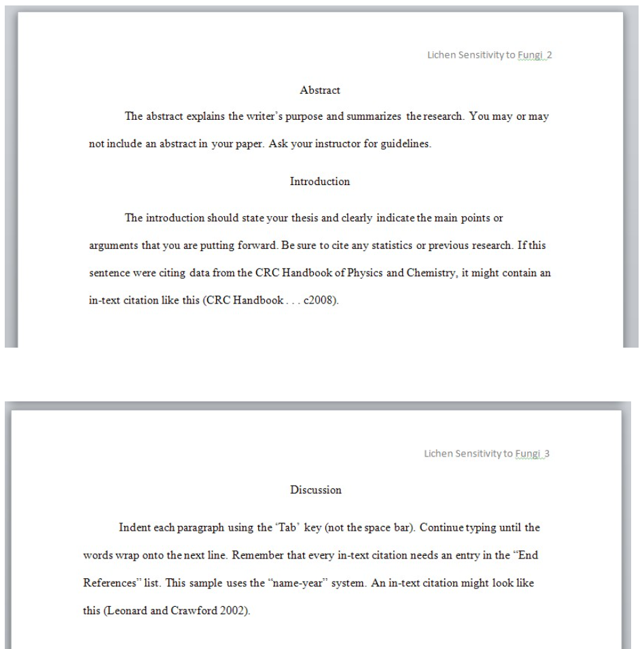
Information on formatting paper obtained from Loyola Notra Dame Library https://guides.lndlibrary.org/c.php?g=359989&p=2431113

